# Topic: Dimension Reduction (PCA)

**Instructions**

Please share your answers filled inline in the word document. Submit Python code and R code files wherever applicable.

Please ensure you update all the details:

**Name: Batch Id:**  **Topic: Principal Component Analysis**

1. **Business Problem**
   1. **Objective**
   2. **Constraints (if any)**
2. **Work on each feature of the dataset to create a data dictionary as displayed in the below image:**

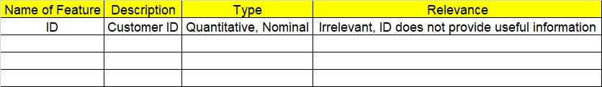

**2.1 Make a table as shown above and provide information about the features such as its Data type and its relevance to the model building, if not relevant provide reasons and provide description of the feature.**

**Using R and Python codes perform:**

1. **Data Pre-processing**

**3.1 Data Cleaning, Feature Engineering, etc.**

1. **Exploratory Data Analysis (EDA):**
   1. **Summary**
   2. **Univariate analysis**
   3. **Bivariate analysis**
2. **Model Building**
   1. **Build the model on the scaled data (try multiple options)**
   2. **Perform PCA analysis and get the maximum variance between components**
   3. **Perform clustering before and after applying PCA to cross the number of clusters formed.**
   4. **Briefly explain the model output in the documentation.**

1. **Share the benefits/impact of the solution - how or in what way the business (client) gets benefit from the solution provided.**

# Note:

The assignment should be submitted in the following format:

* R code
* Python code
* Code Modularization should be maintained
* Documentation of the model building (elaborating on steps mentioned above)

**Problem Statement: -**

Perform Principal component analysis and perform clustering using first 3 principal component scores (both Hierarchical & K-Mean clustering). Use Scree plot or elbow curve and obtain optimum number of clusters and check whether we have obtained same number of clusters with the original data

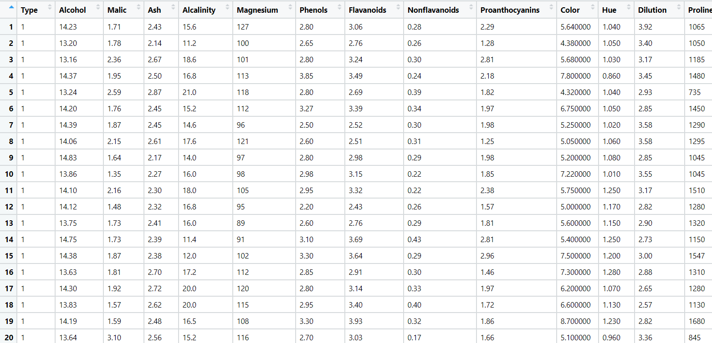

**Problem Statement: -**

A Pharmaceutical drug manufacturing company is studying on a new medicine to treat Heart diseases, it has gathered data from its secondary sources, and it would like you to provide high level analytical insights on the data, its aim is to segregate patients depending on their age group and other factors as given in the data, perform PCA and Clustering Machine learning Algorithm on the dataset given, and check if the clusters formed before and after PCA are same and provide a brief report on your model. You can also explore more on ways to improve your model.

Note: - This is just a snap shot of the data, the datasets can be downloaded from Aispry LMS in the Hands on Material section.

